**ĐỀ THI TIẾNG ANH Mã đề: 20**

**Trình độ A2**

Họ và tên thí sinh: ……………..……………………………………………………….……………………………………………………………….

Số báo danh: ……………..…………………………………………...……. Phòng thi số: …………………………….…………………

**PAPER TWO LISTENING (Approximately 15 minutes)**

**PART 1: Questions 1 – 5**

*There are five questions in this part. For each question there are three answer choices and a short recording. Tick (***√***) the correct answer. You will hear the piece twice.*

*Example:* ***How many people were at the meeting?***

*A. 3 B. 13* **√** *C. 30*

**1.** How will they travel to pop concert?

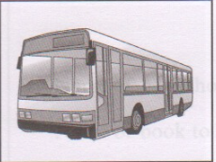 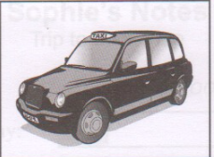 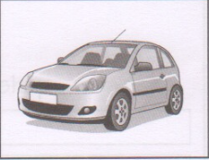

**A** □ **B** □ **C** □

**2.** What was the weather like on Beth’s holiday?

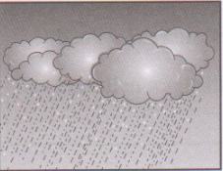 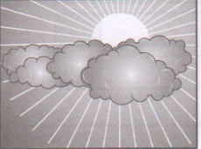 

**A** □ **B** □ **C** □

**3.** Where has the teacher put the dictionaries?

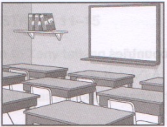 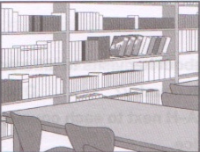 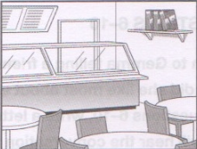

**A** □ **B** □ **C** □

**4.** Where did Pau go running yesterday?

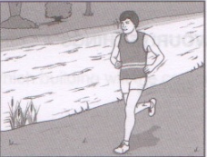 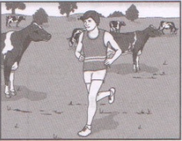 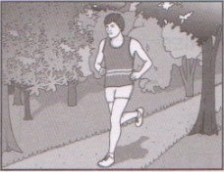

**A** □ **B** □ **C** □

**5.** What does Karen still need to get for the school play?

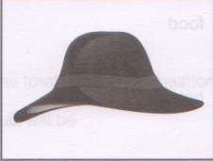 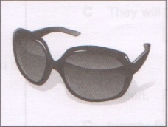 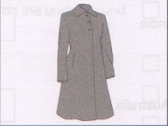 **A** □ **B** □ **C** □

**PART 2:** **Questions 6-10**

*Listen to Gemma telling a friend about her visits to different countries. What did she like most about each country. For questions 6-10, write a letter A-H next to each person. You will hear the conversation twice.*

|  |  |  |
| --- | --- | --- |
| **EXAMPLE** | **ANSWER** |  |
| **0**  France | **H** |  |
| **COUNTRIES** |  | **FAVOURITE THINGS** |
| **6**  Italy  **7** Mexico  **8**  India  **9**  Australia  **10** Canada |  | **A** animals  **B** beach  **C** countryside  **D** food  **E** hotel  **F** shops  **G** sport  **H** weather |

**PART 3:** **Questions 11-15**

*Listen to Tony talking to Lisa about a science club competition*

*For questions* ***11-15****, tick (√)* ***A****,* ***B****, or* ***C****. You will hear the conversation twice.*

Example: **0.** Tony says the competition is on

A. Monday

B. Tuesday

√C. Wednesday

**11.** Which building will the competition be in?

A. the school

B. the town hall

C. the university

**12.** How has the team decided to get there?

A. They will catch a bus

B. They will walk

C. They will go on the underground

**13.** The total number of the questions in the quiz will be

A. five

B. fifteen

C. twenty-five

**14.** Tony’s favourite area of science is

A. biology

B. chemistry

C. physics

**15.** Winners of the competition get

A. T-shirt

B. cinema tickets

C. a box of chocolate